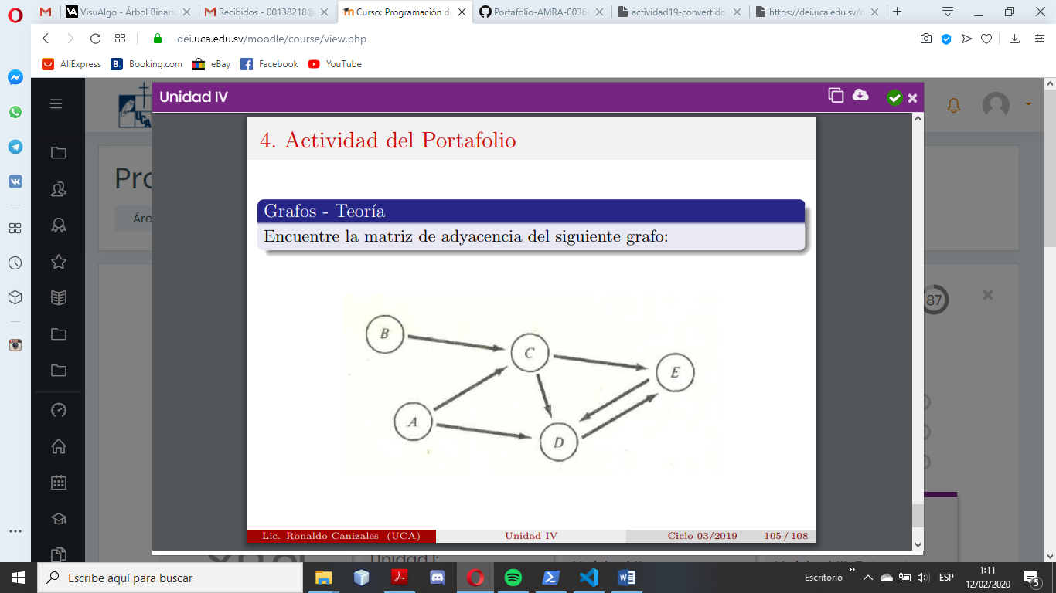

|  |  |  |  |  |  |
| --- | --- | --- | --- | --- | --- |
|  | A | B | C | D | E |
| A | 0 | 0 | 1 | 1 | 0 |
| B | 0 | 0 | 1 | 0 | 0 |
| C | 0 | 0 | 0 | 1 | 1 |
| D | 0 | 0 | 0 | 0 | 1 |
| E | 0 | 0 | 0 | 1 | 0 |